Screenshots for currency converter interface

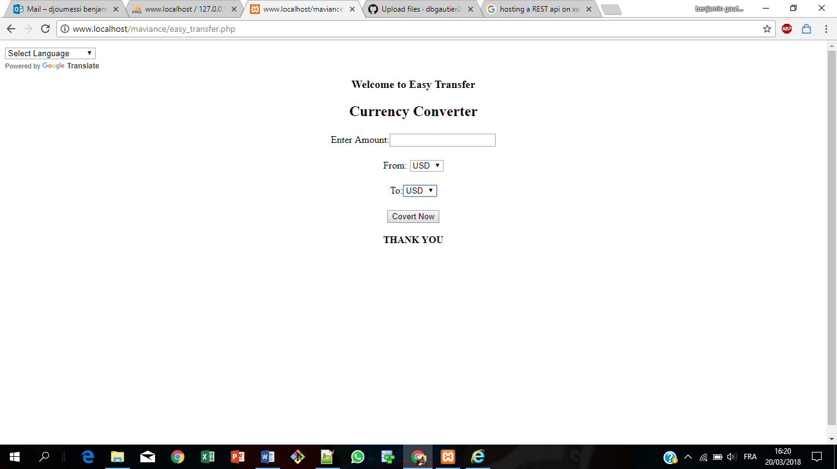

The figure above shows the first page given to the user where he choses the currency and amount he has.

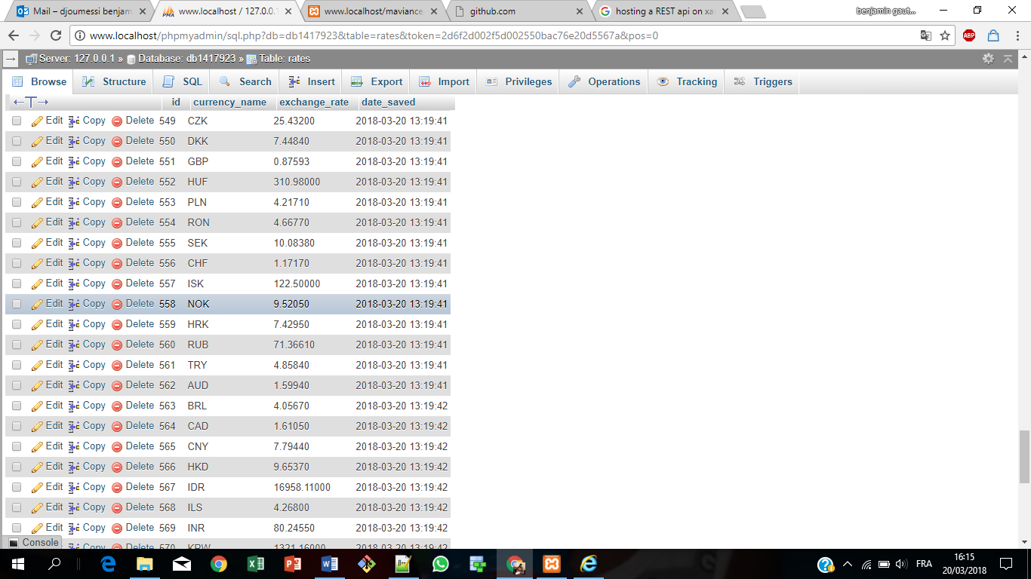

The figure above shows how the data base is populated by a call to the API of the European Central Bank.

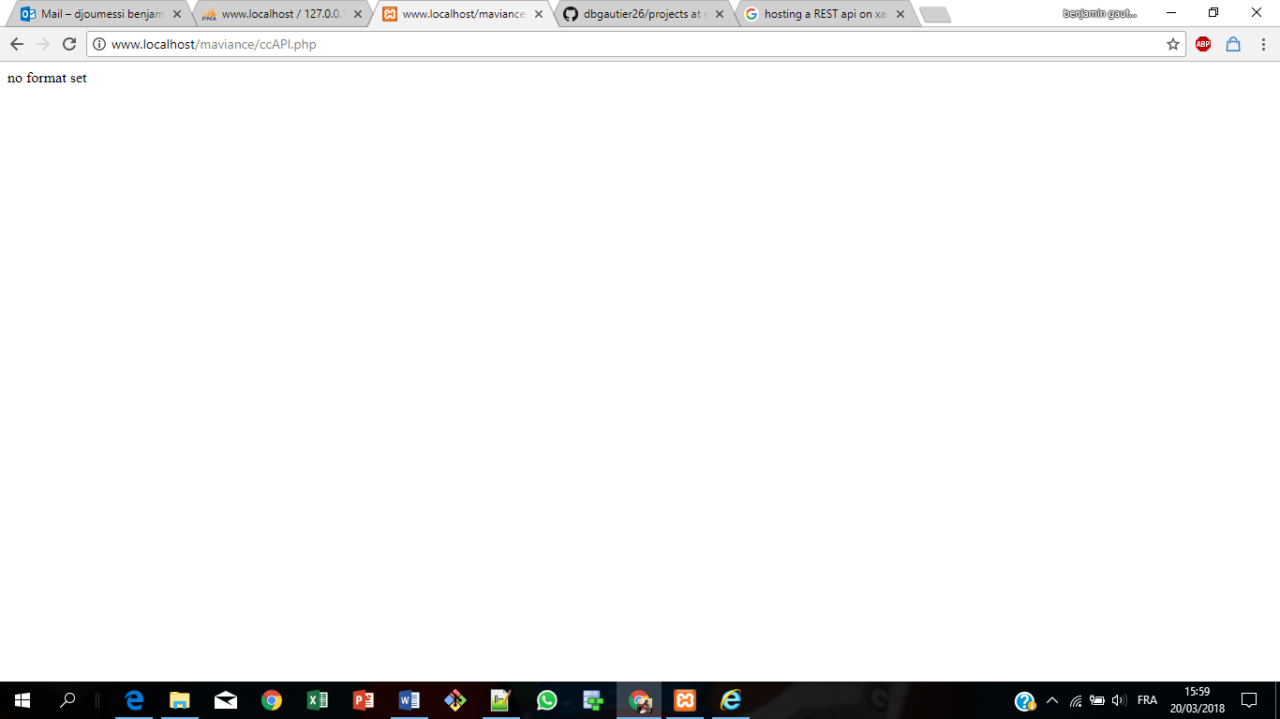

The figure above shows the error message displayed when parameters not set correctly.

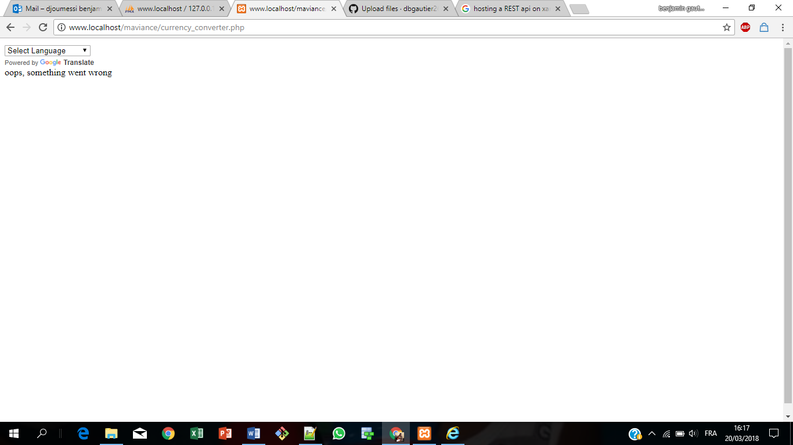

The figure above shows the error message displayed when the service could not access the API to render the information to the user.